School Reform Commission Approves Measure to Place Social Workers in Select Public Schools
Posted on August 17, 2017
Categories: Press Releases
PHILADELPHIA — The School Reform Commission of The School District of Philadelphia on Wednesday voted to approve a measure that would provide social workers for 22 public schools for the 2017-2018 school year, thanks to a new pilot program designed to improve and expand behavioral health services for students.
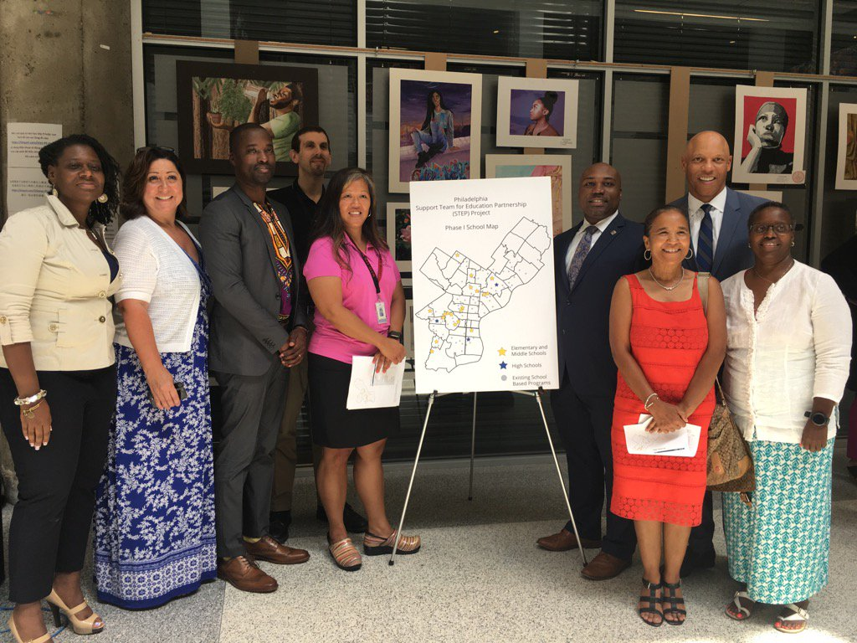
Dr. William R. Hite, superintendent, stands with some of our excited principals whose schools will get social workers this fall.
The Philadelphia Support Team for Education Project (STEP) is the result of a partnership among the District, the Department of Behavioral Health and Intellectual Disability Services (DBHIDS) / Community Behavioral Health, and the City of Philadelphia. The goal is to improve the continuum of behavioral health services, ranging from prevention and at-risk services to intensive treatment options, to best serve public school students.
“So many of our students are dealing with adult issues,” said Dr. William R. Hite, Superintendent of The School District of Philadelphia. “You can’t educate a child in crisis. But by intervening early and preventing crises in the first place, we can make sure our students get the supports they need and do not miss important instructional time.”
After social workers are added to schools, in later phases of the project, a school behavioral consultant, a case manager and a family peer specialist will also be added to the schools to complement and support the school counselors, school nurses, special education liaisons, school psychologists and others who are already in the schools. These teams will also help existing school staff identify behavioral issues as early as possible and connect students and families to valuable resources.
“This pilot will help show our children that we don’t just care how they do in school. We care about them,” said Mayor Jim Kenney. “We want to help them thrive in every area of their life, and we want to support their families too.”
The $1.2 million grant from Community Behavioral Health will fund the first stage of the project. Employees will work for the District and will report to school principals.
“This program will allow us to look at those youth who are at risk for behavioral health challenges as well as to help determine those students who are really in need of behavioral health treatment,” said DBHIDS Commissioner David T. Jones. “The goal is to mitigate or decrease the behavioral health challenges that may interfere with the academic achievement of our students. So, we truly believe that this will be a tremendous opportunity to help youth throughout Philadelphia.”
The District and Community Behavioral Health will monitor the implementation of the program and evaluate the strategy’s effectiveness in schools.
“We cannot overstate the importance of making sure students and families have access to behavioral health resources, and I am proud to support this exciting partnership moving forward,” said Commissioner Estelle Richman of the School Reform Commission.
The schools receiving social workers include:
Lewis C. Cassidy
William Cramp Elementary
Franklin S. Edmonds
Lewis Elkin Elementary
Frankford High School
Edward Gideon
Alain Locke
James Logan Elementary
Morton McMichael Elementary
General George C. Meade
Penrose
Samuel Powel Elementary
Science Leadership Academy Middle School
Philip Sheridan Elementary
South Philadelphia High School
Southwark
Allen M. Stearne
Edward T. Steel
William Tilden Middle School
Martha Washington
West Philadelphia High School
Belmont Charter School

